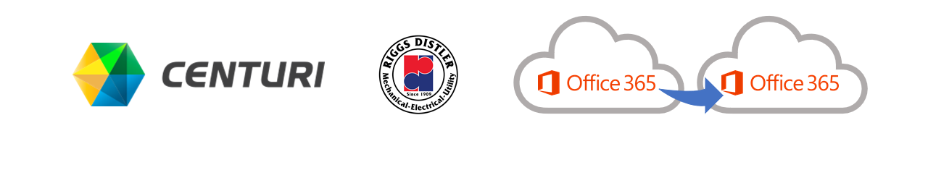

In the event that you encounter any issues, you can use this guide to try some quick fixes.
Riggs Distler is moving to the Centuri Microsoft 365 tenant! Email, OneDrive, SharePoint, and Teams content is being migrated to Centuri’s environment and the go-live is scheduled for December 20, 2021.

How will I know when I can access my email?
During this time, you can log onto the network but you cannot use email, Teams, and One Drive. You can access the intranet and there will be a status of the migration.
Status will be here: Information Technology (IT) – Riggs Intranet (riggsdistler.com)

What do I need to do?
Read and download these instructions to your desktop so that you will have access to it during the cutover.

Outlook and OneDrive
When the cutover occurs on December 17, 2021, Outlook and OneDrive for Business will disconnect and there will be a planned service interruption as the transfer is finalized.
Once the transfer is complete, your email account should automatically set up on your laptop, desktop, or mobile phone. If you encounter problems, you can follow the procedures outlined below to remove and restore your email profile and OneDrive client. If you continue to have issues, please contact the help desk.

SharePoint and Teams
On December 17, 2021, at 5 PM, the day of cutover stop making any changes or updates to list items or documents in SharePoint and Teams and check in all documents you may have checked out.
On December 20, 2021, you will be notified when to begin accessing email, OneDrive, SharePoint, and Teams. Be sure to update any bookmarks you have in your browsers to point to the new locations.

How do I do this?
Detailed step-by-step instructions are included below in the following pages.

Samsung Phone/Samsung Tablet: Remove and Re-configure Android Email after mailbox Migration

Remove your old email profile from your phone.
- Open the Mail app   | - Select the 3 lines menu in the top right corner of the screen, next to Inbox.  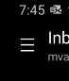 | - Select the cog in the top right to open Settings.  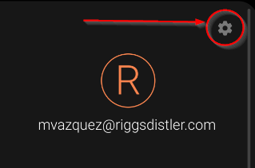
- In email settings, select on your RiggsDistler.com email address.  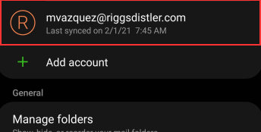 | - Select Remove.  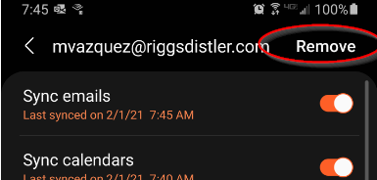

Add New Email Account
- From Email Settings – Select Add Account.   | - From the Set Up Email window, choose Office365.  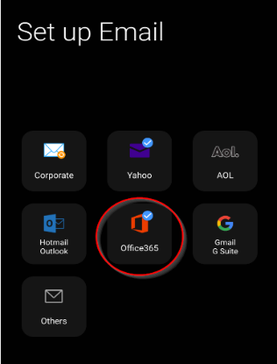 | - You will be prompted to sign into your Account by Microsoft. Enter your Riggs email address.  Example: jdoe@riggsdistler.com  Select Next. If prompted for Work & School or Personal Account – Choose Work or School.  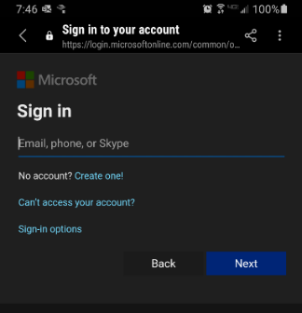
- You will be prompted to Enter password. Enter your Riggs login password and select Sign In.  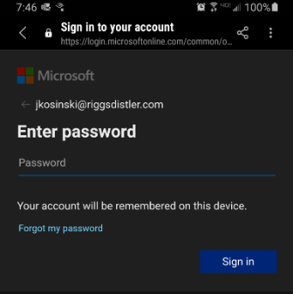 | - You will be asked to apply security settings. Select Apply.  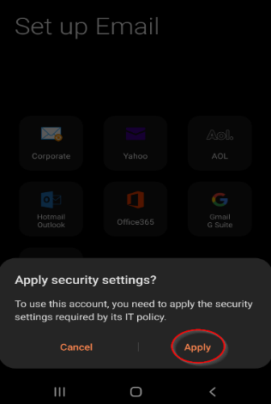 | - You will be prompted to choose sync settings on the Manual setup screen. Select Done to accept the defaults.  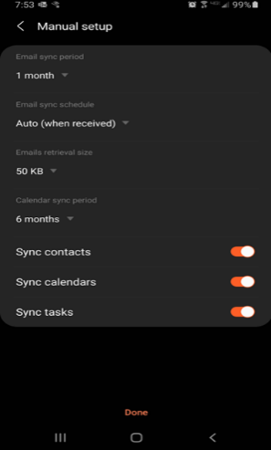
- Activate device admin app - You will be notified of Device Administration settings. Select Activate.  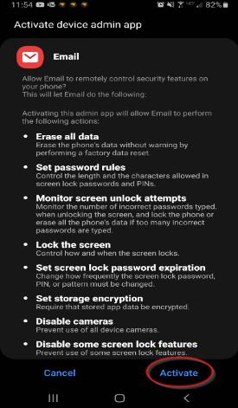 | - You will be asked if you to give this account a name. Select Done to accept the default name (your email address). | - The mail app should open to your inbox. Allow a couple minutes for mail to sync and messages will start to appear in your inbox.  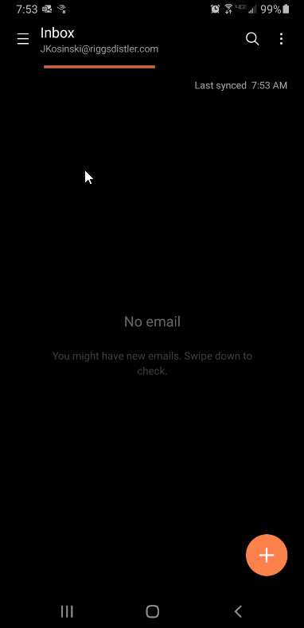

iPhone/iPad: Remove and Re-configure Email on iPhone/iPad after mailbox Migration

Remove your old email profile from your phone
- Open Settings. | - Scroll down and tap Passwords and Accounts.  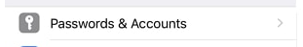 | - Select your RiggsDistler email account.
- Select Delete Account and confirm.

￼

Add new email account
- Open Settings | - Scroll down and tap Mail.  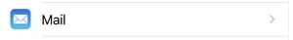 | - On the Mail screen, tap Accounts.  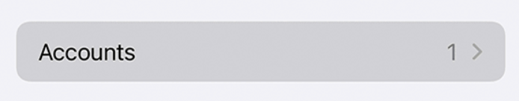
- Tap Add Account and select Outlook.com | - You will be prompted to sign in. Enter your Riggs email and password. | - If you see Next, tap it and wait for the account to be verified. Otherwise, tap Save to continue.
- Your Mail should begin syncing with Outlook and will be available in a few minutes.

Email on your pc: Outlook on Windows 10 Desktop

- Make sure Outlook is closed before proceeding. | - Select the Start button, and in the search box type Control.  - Select Control Panel in the “Best match” results.  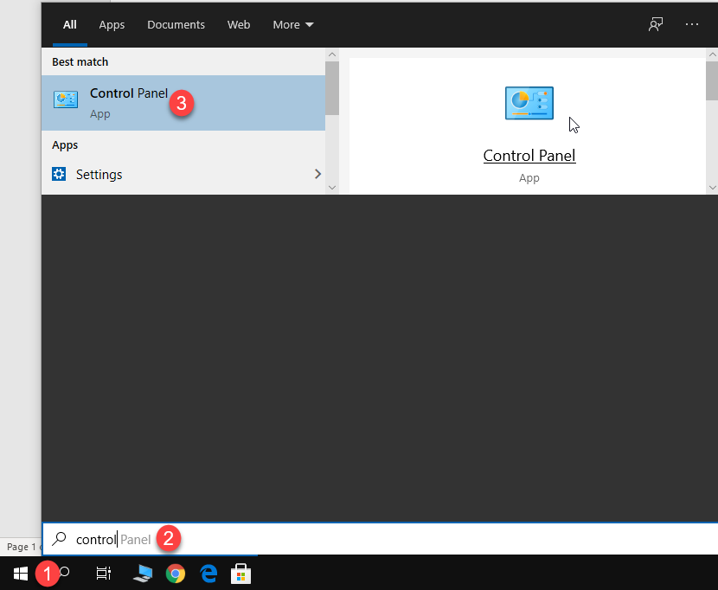
- In the Search Control Panel box type mail.  - Select Mail (Microsoft Outlook 20XX) in the search results.  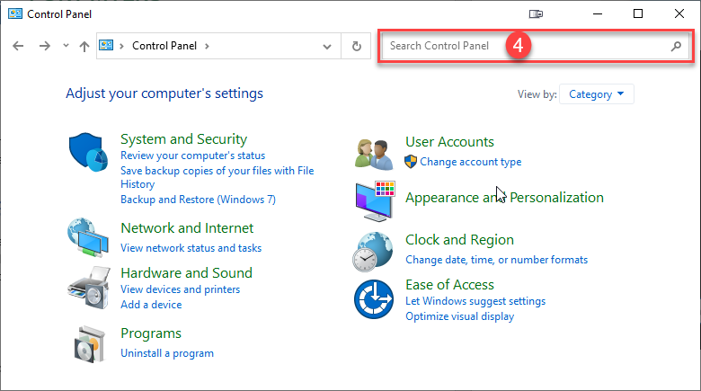  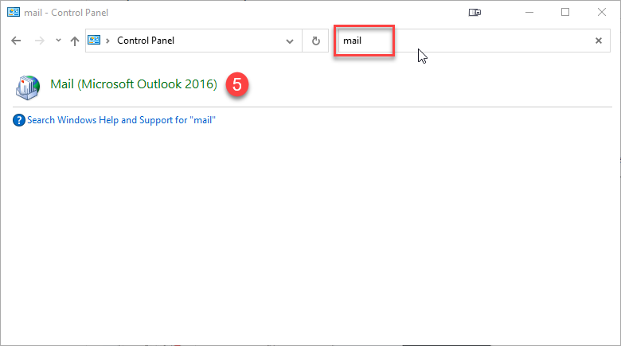 | - This will open the Mail Setup window. Select Show Profiles…  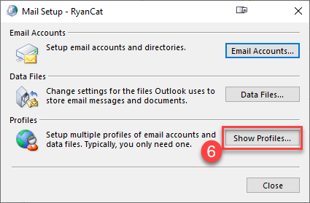
- Select Add…  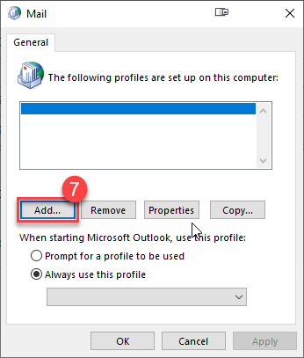 | - Select New in the Profile Name field.  - Select OK.  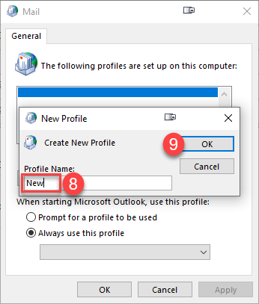
- In the next window, fill out your name, email address, and password.  - Select Next.  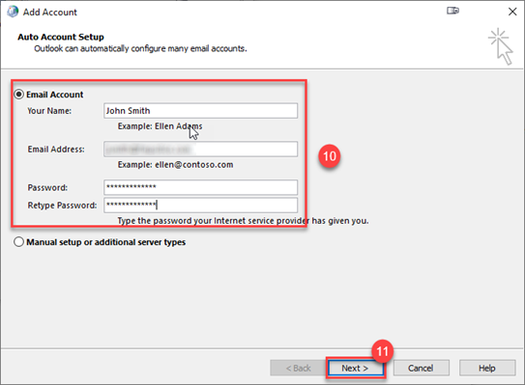 | - The account will proceed to set up. When it completes select Finish.  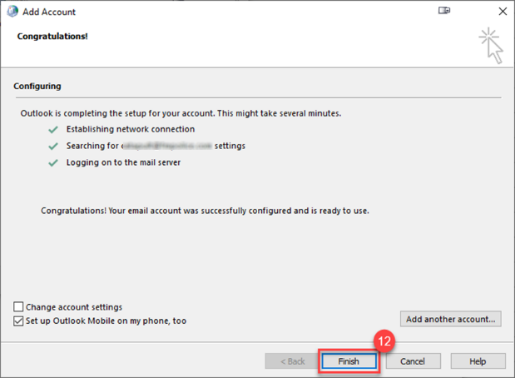
- IMPORTANT: Change the dropdown to the New name you created.  - Select Apply.  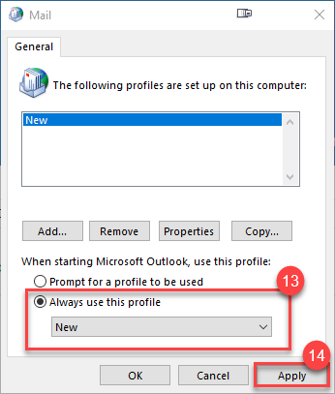 | The next time you open Outlook, you will now be connected to your new mailbox in the Centuri Microsoft 365 environment.

OneDrive for Business Desktop Sync Client

- During the cutover event your OneDrive client will disconnect. You may be required to unlink the account and link to the new Centuri ODfB tenant. | - Select the blue cloud icon in the system tray and select Help & Settings.  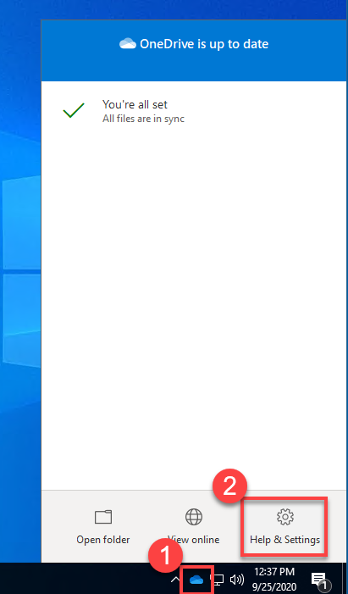 | - Select Settings.  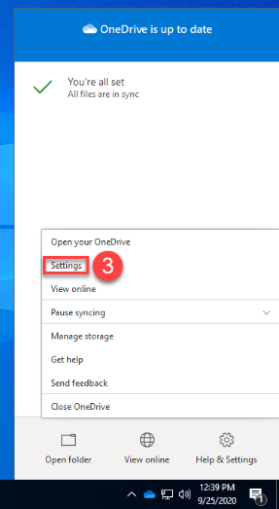
- From the Account tab, select Unlink this PC.  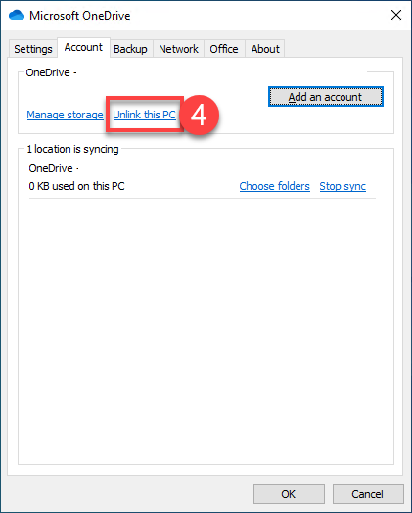 | - Select Unlink account.  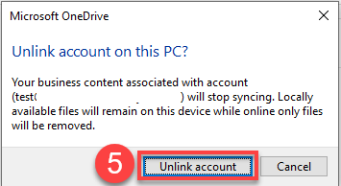 | - The Set up OneDrive menu should appear. Enter your Riggs email address.  - Select Sign In.  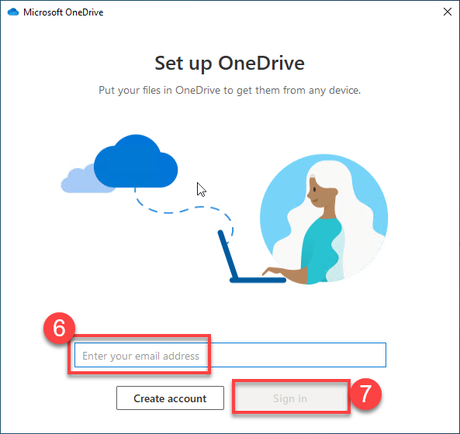
- Complete the sign in process by entering your credentials, and accept all the default options, and select “Next”. Keep selecting “Next” until you reach the end of the wizard, and then you may select the X in the top right corner to close the wizard. | 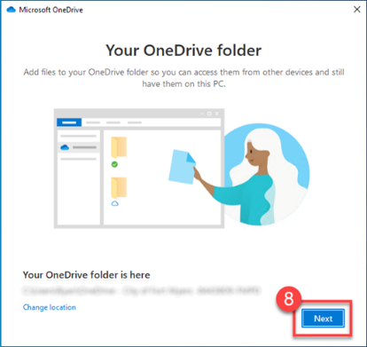

Microsoft Teams
When using the desktop version of Microsoft Teams if the app does not automatically take you to the login screen, you will need to logout of the old tenant and log back in to reconnect to the new tenant.
Note: Only the Teams document content is being migrated, none of the chat history is migrated, nor are the custom tabs. You will need to re-add any custom tabs you had in your Team in the old tenant.
To logout and login to the Teams desktop app:
- Select your account icon in the top right of the screen and Sign out.  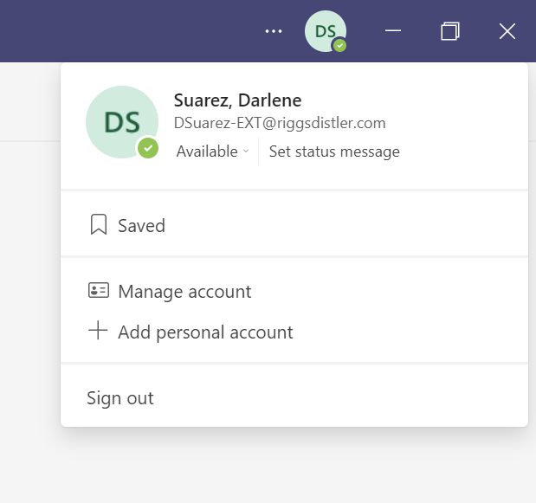 | - When the login screen appears, enter your Riggs email address, and select Next.  - Enter Password and sign in.  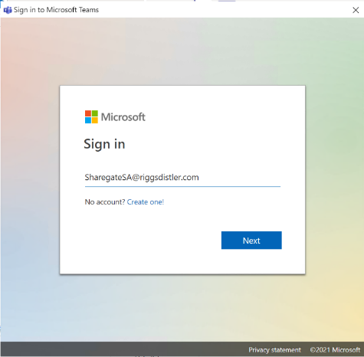

IT Contacts
In the event that you still have an issue, you can contact one of the following based on the first letter of your last name:
- A to D - Thang Doan: 267-254-8391
- E to L - Jeff Bowman: 856-793-8610
- L to R - Enrique Ochoa: 860-816-4095
- S to Z - Mike Vazquez: 215-910-2101
- Luciano Montanez: 856-813-6093
- Jason McKay: 856-685-9476

